This is one of the interesting data preprocessing in which we find the covariance of each feature with another feature.

Therefore for a data matrix of dimensions n*d, the **co-variance** matrix will be of dimension d*d, because we plot each feature against each feature and therefore co-variance matrix will be a square matrix.

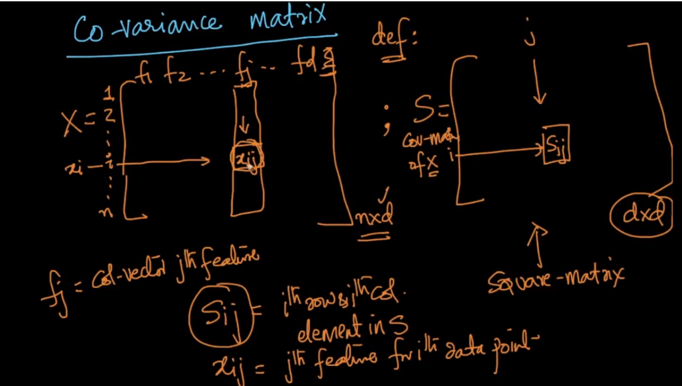

Below figure shows two properties of covariance:

1. If we are finding covariance of same RV X, then it will be equal to variance.

Or we can say if we find the co-variance of one feature with itself then it will be equal to variance of that feature.

1. Covariance (SL, PL) = Covariance (PL, SL)

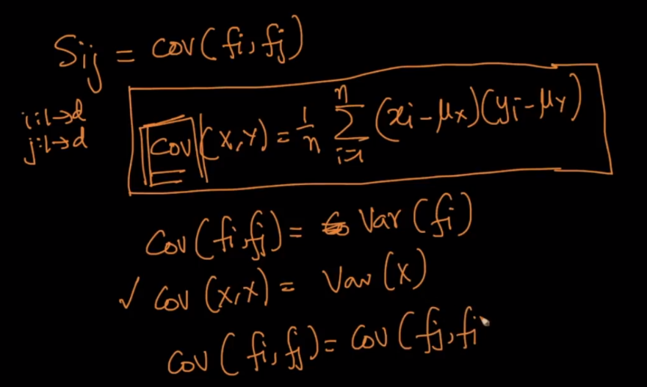

Below image shows that in co-variance matrix the diagonal will be the co-variance of a feature with itself, hence diagonal represent the variance of the features.

Co-variance matrix is also called symmetric matrix because in symmetric metrix A21 = A12.

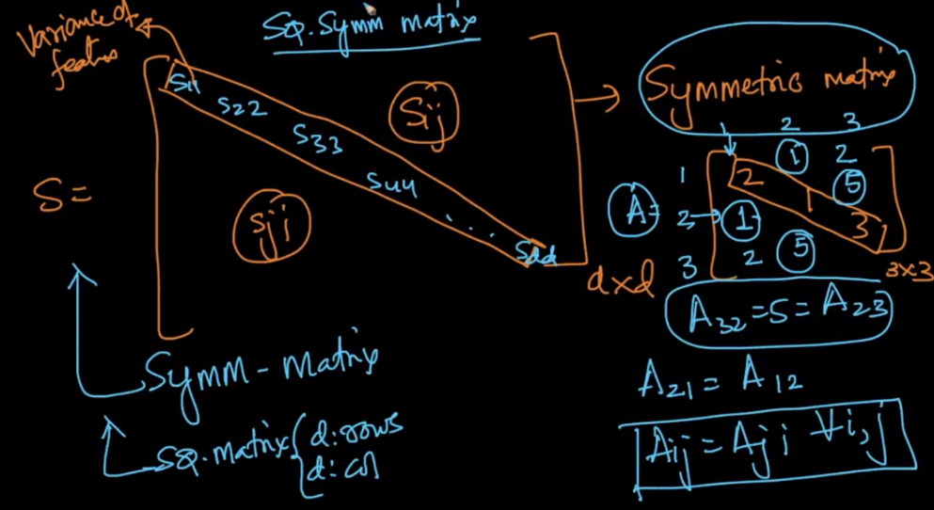

For Finding Co-variance of any data matrix first we’ll perform **column standardization**, to bring the mean of all feature to 0.

Since after standardization mean becomes 0, so we’ll remove mean from co-variance formula,

Hence now for co-variance of two features we simply multiply their corresponding points and sum up and then we divide by n.

And therefore we can also say that covariance of two features f1 and f2  will be dot product as:

**( f1 . f2 ) / n**  
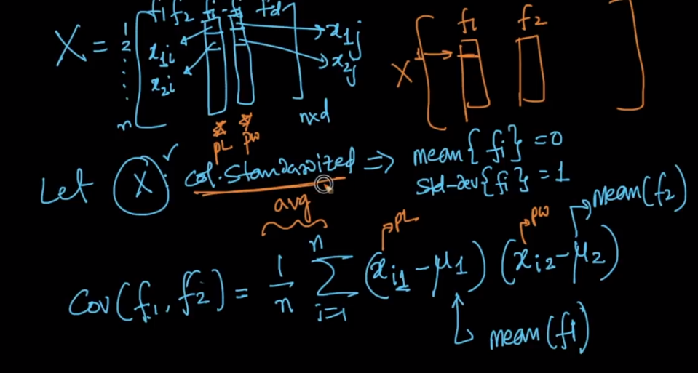

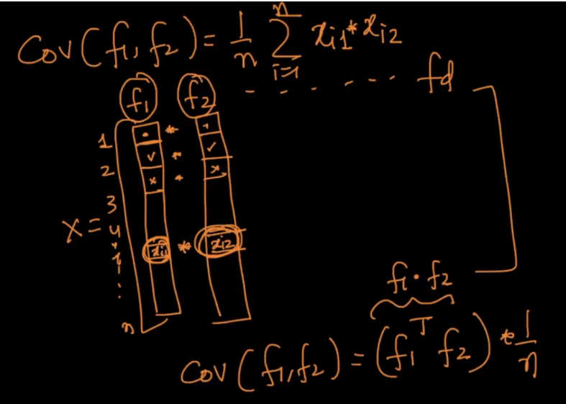

Since after standardization mean becomes 0, and we are making co-varinace matrix just by using value of data-matrix, therefore we can also say tha co-variance matrix can be (XT * X)/n

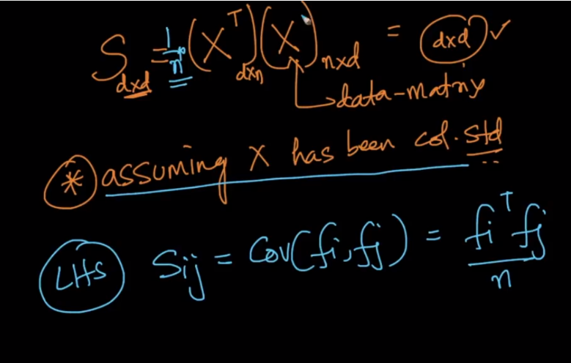

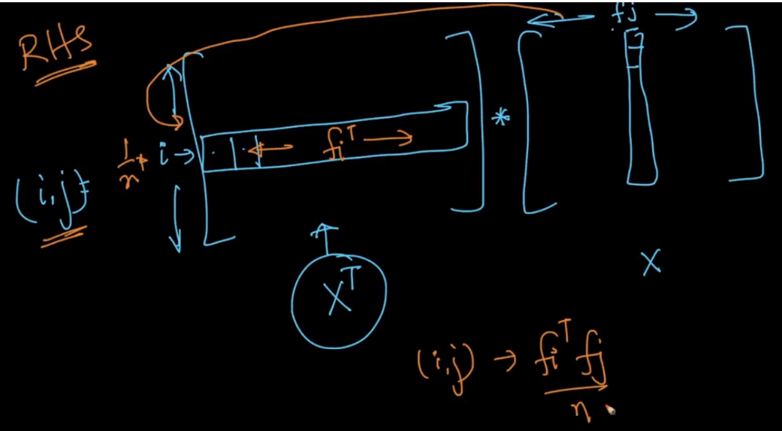

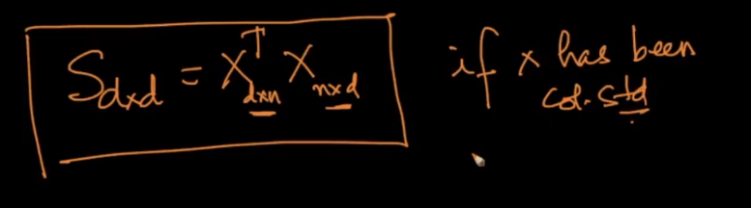

**Notes**:

* In co-variance, it’s impacted by scale or units of measurement, but in calculating co-variance matrix we are standardizing before finding co-variance, that means we are removing the impact of scaling so therefore in such case co-variance is similar to co-relation.

Covariance is nothing but a measure of correlation. On the contrary, correlation refers to the scaled form of covariance.

The value of correlation takes place between -1 and +1. Conversely, the value of covariance lies between -? and +?. So, if the random variables are standardized before calculating the covariance then covariance is equal to the correlation and has a value between -1 and +1.